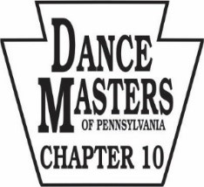
Dance Masters of Pennsylvania
Fall Convention / Tuition Scholarships
September 25, 2022

101 Mall Blvd, Monroeville, PA 15146
(412) 373-7300

Schedule / Classes with Justin Myles

Registration 8:00 AM

Petite & Junior Scholarship Audition (Ages 7-9, 10-12) 8:30 – 11:30 AM

Closed Classes (Senior/Teen Tuition Scholarship Students and Membership) 8:30 – 11:30 AM

Class Structure 1 Hour Contemporary
1 Hour Tap
1 Hour Body Percussion
***order of classes may change

Lunch and Grand Body Meeting/Members 11:30 – 1:00 PM
Lunch Break Lunch not provided 11:30 – 12:30 PM

Teen & Senior Scholarships Audition (Ages 13–15, 16 & up) 1:00 - 4:00 PM

Closed Classes (Petite & Junior Tuition Scholarship Students and Membership) 1:00 - 4:00 PM
Class Structure 1 Hour Contemporary
1 Hour Tap
1 Hour Body Percussion
***order of classes may change

Final Post Mark Date: September 2, 2022

